RISE Parent Information Sheet

What is RISE?
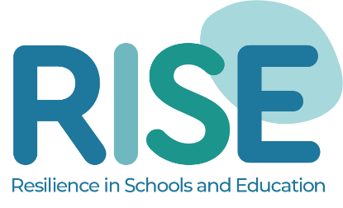
Resilience is a vital human characteristic that enables us to cope when things go wrong, learn from our mistakes and grow through overcoming challenges. Resilient people have better wellbeing, more success in their education and careers, and are generally better able to manage adversity. RISE (Resilience In Schools & Education) is a whole school program designed to assess and build your child’s resilience. We believe that RISE can fundamentally improve your child’s school experience and equip them with skills that will serve them well for the rest of their lives and we are very happy to be able to bring RISE to NAME OF YOUR SCHOOL. The RISE assessment helps to identify your child’s areas of strength and need, meaning that we put whole-class, small group or individual support in if and where may be beneficial for them. Please do contact your child’s teacher if you have any questions or would like them not to be included in this assessment.

The 8 Pillars of Resilience

Connectedness
To have close connections and feel secure in trusted adult and peer relationships.

Confidence
To assertively try new things and not be afraid to make mistakes.

Character
To keep going, and be confident they can affect positive change in their lives.

Coping Skills
To have the skills to recognise and manage any difficult emotions.

Contribution
To want to help and support others, and feel good about
doing good.

Control
To feel more in control of their lives and let go of trying to control the uncontrollable.

Competence
To develop, recognise and feel secure with their strengths.

Enjoyment
To experience moments of joy each day to build positive & enthusiastic thinking.

Where do I find out more?
To find out more about RISE and its creators, please visit www.edpsyched.co.uk/rise. Also, feel free to check out our parent hub for lots of useful advice, support and video content designed for parents at www.edpsyched.co.uk/parent-hub.

